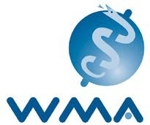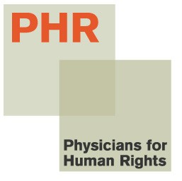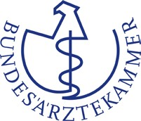

November 19, 2013

Minister of Health, Dr. Mehmet Müezzinoğlu
Mithatpaşa Cad. No: 306434 Sıhhıye / ANKARA
Phone: +90 312 585 10 75, E-mail: ozelburo@saglik.gov.tr

Dear Dr. Mehmet Müezzinoğlu,

As physicians, we are writing to express our grave concerns that the Turkish parliament is considering a draft health law that would criminalize the provision of emergency health care in Turkey. As you may know, after debates in the Parliamentary Commission on Family, Labour and Social Affairs, Article 33 was recently revised and sent to the General Assembly as:

“All practices and procedures related to the delivery of health services shall be under
the scrutiny of the Ministry of Health. With the exception of health services in emergency
situations by authorized and competent persons until the arrival of formal health services,
those who deliver or commission others to deliver health services without proper license
shall be subject to imprisonment from one to three years and administrative fine equivalent
to that of twenty thousand days.”

This would criminalize independent medical care by qualified practitioners throughout Turkey and provide the Ministry of Health with unprecedented control over health care practices in Turkey. In addition, international standards for emergency medical care are based on medical need, not the presence or absence of medical transport. According to Article 33 of the draft law, the presence of state ambulances at a demonstration will be considered grounds not only to prevent emergency medical care by competent, independent clinicians, but also to prosecute emergency medical responders acting under the International Code of Medical Ethics to provide care to those in need.

In our July 12, 2013 letter to you, we expressed our concern that the Ministry of Health failed to provide adequate medical care to injured demonstrators – as it does in earthquakes and other medical emergencies. In the absence of emergency medical services by the Ministry of Health, thousands of independent physicians and other medical personnel provided emergency care as individuals through the organization of the Turkish Medical Association. Unfortunately, the Ministry of Health required medical personnel to report the names of injured demonstrators and medical personnel providing care to the injured, which were used to make arbitrary arrests of demonstrators and emergency medical responders.

International standards in human rights and medical ethics make it clear that doctors, nurses, paramedics, and other health workers must be able to carry out their professional responsibilities to provide emergency medical care to those in need without interference or fear of reprisal. The Ministry of Health and the Turkish government have a duty to support and protect health workers who are discharging their moral, ethical, and professional responsibilities to provide care for the sick and injured. Article 33 of the draft health law is not only inconsistent with international standards of medical ethics, but is also inconsistent with Articles 97 and 98 of the Turkish Penal Code, which makes it a crime for medical personnel to neglect their duty of providing emergency medical care to those in need.

We call upon you, Minister Müezzinoğlu, and the Turkish parliament to:
- Call for the elimination of Article 33 from the draft health law and the exclusion of any provisions that would undermine independent, ethical, non-discriminatory care to those in need;
- Respect articles 97 and 98 of the Turkish Penal Code;
- Repeal the recent Ministry of Health circular requiring medical personnel to report the names of injured demonstrators and medical providers to authorities; and
- Support the independence and autonomy of the Turkish Medical Association and the Human Rights Foundation of Turkey for their critical contributions to the health and human rights of Turkish citizens. These organizations are highly respected by the international medical community for their integrity and the quality of their work.

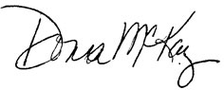
Yours Sincerely,

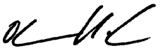
Donna McKay, Executive Director, Physicians for Human Rights

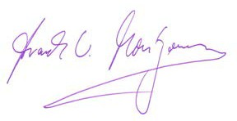
Dr. Otmar Kloiber, Secretary General, World Medical Association (WMA)

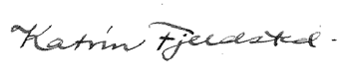
Prof. Dr. Frank Ulrich Montgomery, President, German Medical Association (Bundesärztekammer, GMA)

Dr. Katrin Fjeldsted, President, Standing Committee of European Doctors (CPME)

CC:
President of Turkish Grand National Assembly (TGNA), Mr. Cemil ÇİÇEK, TBMM
06543 Bakanlıklar – ANKARA, Fax: 90 312 4205165, E-mail: iletisim-tbmm@hotmail.com, baskanlik.tbmm.gov.tr, cemil.cicek@tbmm.gov.tr

World Medical Association. International Code of Medical Ethics. 1949. www.wma.net/en/30publications/10policies/c8.
Turkish Penal Code, Article 97 and 98. See: http://legislationline.org/documents/action/popup/id/6872/preview.

